

# PO1_DGC Calculator

**(GDD)**

**Status**: **Draft**

### **Document Status**

|  |  |  |  |
| --- | --- | --- | --- |
| **Version** | **Status** | **Author** | **Date** |
| 1.0 | Draft | May Abdelsalam | 26/2/2020 |
| 1.1 | Draft | Moamen Ahmed | 27/2/2020 |
| 1.2 | Draft | May Abdelsalam | 27/2/2020 |
| 1.3 | Draft | Areej Ayman Helal | 27/2/2020 |
| 1.4 | Draft | Bishoy Nabil | 27/2/2020 |

**History Table**

|  |  |  |  |
| --- | --- | --- | --- |
| **Version** | **Author** | **Date** | **Change** |
| 1.0 | May Abdelelsalam | 26/2/2020 | Initial creation |
| 1.1 | Moamen Ahmed | 27/2/2020 | Added HAL APIs |
| 1.2 | May Abdelelsalam | 27/2/2020 | Update on Input Output signals, Static Architecture |
| 1.3 | Areej Ayman Helal | 27/2/2020 | Added App APIs. |
| 1.4 | Bishoy Nabil | 27/2/2020 | Added MCAL APIs |

**Reference documents**

|  |  |  |  |
| --- | --- | --- | --- |
| **Reference number** | **Document name** | **Version** | **Status** |
| 1 | PO1_DGC Calculator  (SRS) | V1.7 | Proposed |

## **Table of contents**

1. **Project Description.**
2. **Input Output signals.**
3. **Software features.**
4. **Static Architecture.**
5. **APP Components APIs.**
6. **HAL Components APIs.**
7. **MCAL Components APIs.**

## **Project Description**

The Digital Calculator system will consist of a Power component in the APP layer to turn all the system ON whenever the ON switch is pressed.

The system starts with the Keypad_assignment component waiting for any of the Keypad keys to get pressed. When a switch of the keypad is pressed the Keypad_assignment component will send signals to all of the following components:

1- Math_calc: will calculate the entered operation and send the result to the Display component.

2- Display: will display the entered first operand, operation and second operand.

3- PlayTone: will play a tune every time keypad_assignment component is used.

Software context diagram:

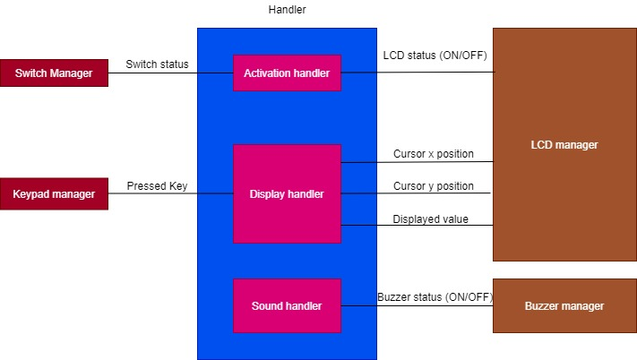

**Input Output signals:**

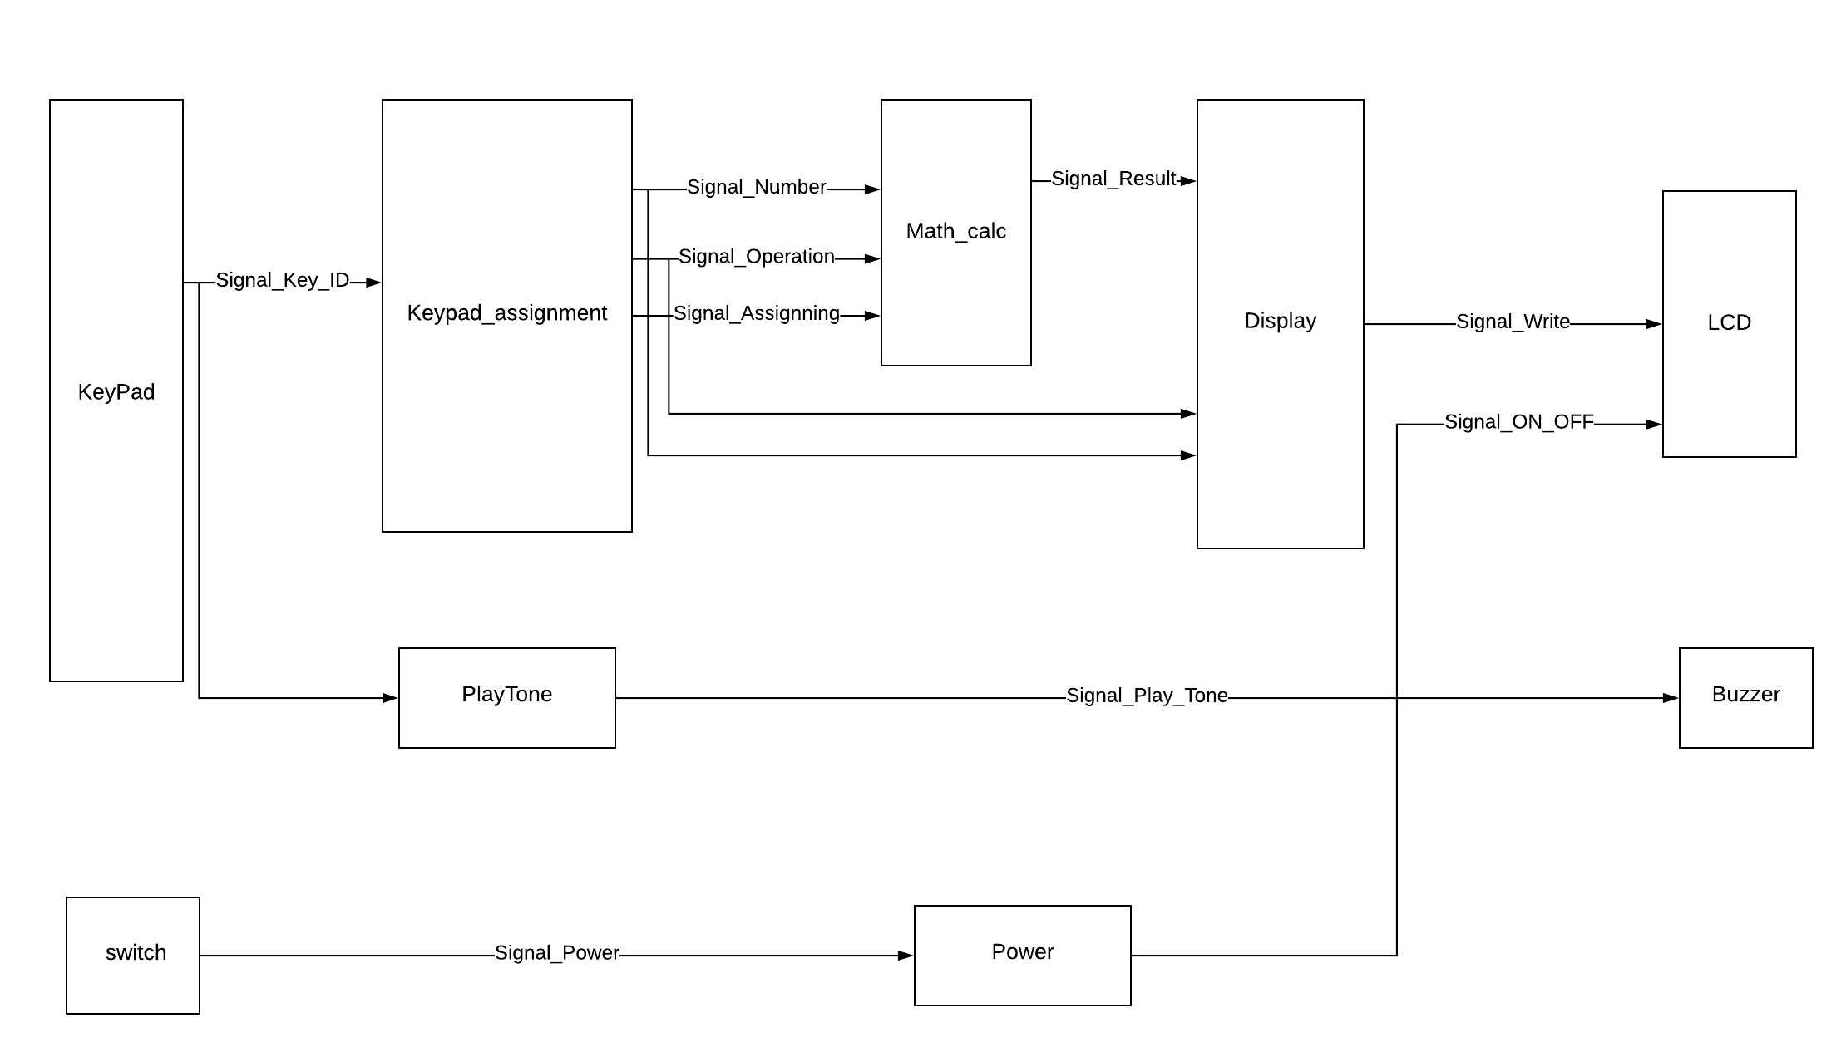

**Static Architecture:**

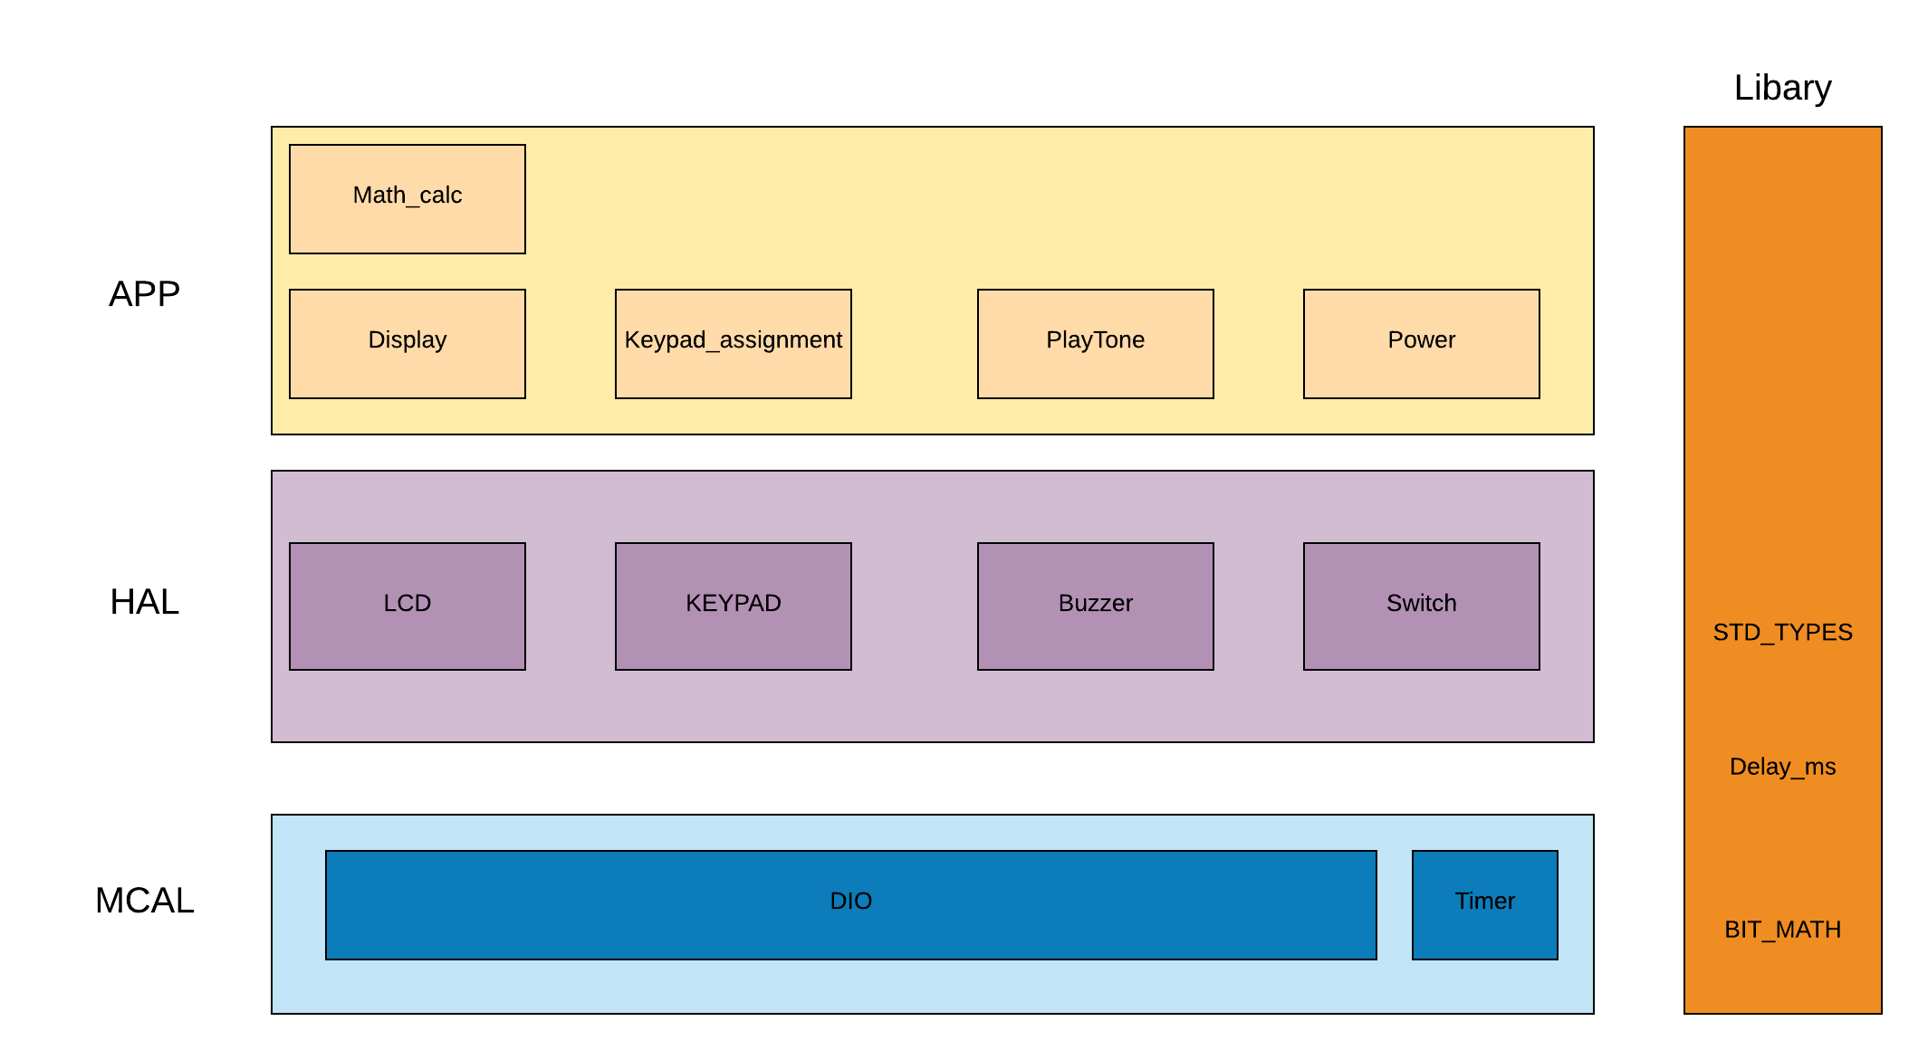

### **APP Components APIs:**

|  |  |  |  |
| --- | --- | --- | --- |
| **Req_ID** | Req_PO1_DGC_GDD_API_APP_Keypad_assignment_001 V1.3 | | |
| **Return Type** | struct | **Input arguments** | u8 Copy_u8PressedKey |
| **Name** | DGC_structKeypadAssignment | | |
| **Description** | It takes the pressed key as an input and returns a struct of numbers and assignment operators. | | |

|  |  |  |  |
| --- | --- | --- | --- |
| **Req_ID** | Req_PO1_DGC_GDD_API_APP_Math_Calc_002 V1.3 | | |
| **Return Type** | u8 | **Input arguments** | struct Copy_structAssignedKeys |
| **Name** | DGC_u8MathCalc | | |
| **Description** | It takes the struct of numbers and assignment operators and applies math operations on them , then returns the result . | | |

|  |  |  |  |
| --- | --- | --- | --- |
| **Req_ID** | Req_PO1_DGC_GDD_API_APP_Display_003 V1.3 | | |
| **Return Type** | void | **Input arguments** | u8 Copy_u8Result , struct ,Copy_structAssignedKeys . |
| **Name** | DGC_voidDisplay | | |
| **Description** | It takes the struct of entered numbers and assignment operations , and the returned result from DGC_u8MathCalc , And Displays all of them on the LCD. | | |

|  |  |  |  |
| --- | --- | --- | --- |
| **Req_ID** | Req_PO1_DGC_GDD_API_APP_Play_Tone_004 V1.3 | | |
| **Return Type** | void | **Input arguments** | u8 Copy_u8PressedKey |
| **Name** | DGC_voidPlayTone | | |
| **Description** | It takes the pressed key as an input and applies a different tone on each key of them whenever it’s pressed. | | |

|  |  |  |  |
| --- | --- | --- | --- |
| **Req_ID** | Req_PO1_DGC_GDD_API_APP_Power_005 V1.3 | | |
| **Return Type** | void | **Input arguments** | u8 Copy_u8PowerPressedKey |
| **Name** | DGC_voidPower | | |
| **Description** | It takes the power pressed key status as an input and then sets the system on or off depending on it . | | |

|  |  |  |  |
| --- | --- | --- | --- |
| **Req_ID** | Req_PO1_DGC_GDD_API_APP_Power_006 V1.3 | | |
| **Return Type** | void | **Input arguments** | void |
| **Name** | DGC_voidInit | | |
| **Description** | It initializes power pins to output. | | |

### **HAL Components APIs**

|  |  |  |  |
| --- | --- | --- | --- |
| **Req_ID** | Req_PO1_DGC_GDD_API_HAL_LCD_001 V1.0 | | |
| **Return Type** | void | **Input arguments** | void |
| **Name** | LCD_voidInit | | |
| **Description** | Initialize LCD pins to output and set the default configurations  (5:8, Blinking: off,Cursor: off, 2 lines: on ) | | |

|  |  |  |  |
| --- | --- | --- | --- |
| **Req_ID** | Req_PO1_DGC_GDD_API_HAL_LCD_002 V1.0 | | |
| **Return Type** | void | **Input arguments** | u8 Copy_u8Command |
| **Name** | LCD_voidWriteCommand | | |
| **Description** | Control the LCD using the commands found in the LCD datasheet | | |

|  |  |  |  |
| --- | --- | --- | --- |
| **Req_ID** | Req_PO1_DGC_GDD_API_HAL_LCD_003 V1.0 | | |
| **Return Type** | void | **Input arguments** | u8 Copy_u8Data |
| **Name** | LCD_voidWriteData | | |
| **Description** | Write a single character to the LCD | | |

|  |  |  |  |
| --- | --- | --- | --- |
| **Req_ID** | Req_PO1_DGC_GDD_API_HAL_LCD_004 V1.0 | | |
| **Return Type** | void | **Input arguments** | u8 Copy_u8Shape[8] |
| **Name** | LCD_voidWriteToCGRAM | | |
| **Description** | Add a custom shape to CGRAM | | |

|  |  |  |  |
| --- | --- | --- | --- |
| **Req_ID** | Req_PO1_DGC_GDD_API_HAL_KEYPAD_001 V1.0 | | |
| **Return Type** | void | **Input arguments** | void |
| **Name** | KEYPAD_voidInit | | |
| **Description** | Initialize keypad pins (1,2,3,4) to input and pins (5,6,7,8) to output | | |

|  |  |  |  |
| --- | --- | --- | --- |
| **Req_ID** | Req_PO1_DGC_GDD_API_HAL_KEYPAD_002 V1.0 | | |
| **Return Type** | u8 | **Input arguments** | void |
| **Name** | KEYPAD_u8GetPressedKey | | |
| **Description** | Returns the current pressed key(1:16) or returns 0 if no key is pressed | | |

|  |  |  |  |
| --- | --- | --- | --- |
| **Req_ID** | Req_PO1_DGC_GDD_API_HAL_BUZZER_001 V1.0 | | |
| **Return Type** | void | **Input arguments** | void |
| **Name** | BUZZER_voidInit | | |
| **Description** | Initialize buzzer pin to output | | |

|  |  |  |  |
| --- | --- | --- | --- |
| **Req_ID** | Req_PO1_DGC_GDD_API_HAL_BUZZER_002 V1.0 | | |
| **Return Type** | void | **Input arguments** | void |
| **Name** | BUZZER_voidSetBuzzerOn | | |
| **Description** | Turn on the buzzer by outputting a high signal on the buzzer pin | | |

|  |  |  |  |
| --- | --- | --- | --- |
| **Req_ID** | Req_PO1_DGC_GDD_API_HAL_BUZZER_003 V1.0 | | |
| **Return Type** | void | **Input arguments** | void |
| **Name** | BUZZER_voidSetBuzzerOff | | |
| **Description** | Turn off the buzzer by outputting a low signal on the buzzer pin | | |

|  |  |  |  |
| --- | --- | --- | --- |
| **Req_ID** | Req_PO1_DGC_GDD_API_HAL_SWITCH_001 V1.0 | | |
| **Return Type** | void | **Input arguments** | void |
| **Name** | SWITCH_voidInit | | |
| **Description** | Initialize the switch pin to input pull up | | |

|  |  |  |  |
| --- | --- | --- | --- |
| **Req_ID** | Req_PO1_DGC_GDD_API_HAL_SWITCH_002 V1.0 | | |
| **Return Type** | u8 | **Input arguments** | void |
| **Name** | SWITCH_u8GetSwitchStatus | | |
| **Description** | Returns 1 if the switch is pressed or 0 otherwise | | |

### **MCAL Components APIs**

|  |  |  |  |
| --- | --- | --- | --- |
| **Req_ID** | Req_PO1_DGC_GDD_API_MCAL_DIO_001 V1.0 | | |
| **Return Type** | Error_Status | **Input arguments** | void |
| **Name** | DIO_Init | | |
| **Description** | Initialize Port A Pins 0:7 to output Initialize Port B Pins 0:7 to Input Initialize Port D Pins 0:3 to output Initialize Port D Pin 4 to input if the function done its purpose return OK if not return NOK | | |

|  |  |  |  |
| --- | --- | --- | --- |
| **Req_ID** | Req_PO1_DGC_GDD_API_MCAL_DIO_002 V1.0 | | |
| **Return Type** | Error_Status | **Input arguments** | u8 Copy_u8Port u8 Copy_u8Pin u8 Copy_u8Mode |
| **Name** | DIO_SetPinMode | | |
| **Description** | Checks which Port and which Pin and set its Mode if the function done its purpose return OK if not return NOK | | |

|  |  |  |  |
| --- | --- | --- | --- |
| **Req_ID** | Req_PO1_DGC_GDD_API_MCAL_DIO_003 V1.0 | | |
| **Return Type** | Error_Status | **Input arguments** | u8 Copy_u8Port u8 Copy_u8Pin u8 Copy_u8Value |
| **Name** | DIO_SetPinValue | | |
| **Description** | Checks which Port and which Pin and set it or reset it if the function done its purpose return OK if not return NOK | | |

|  |  |  |  |
| --- | --- | --- | --- |
| **Req_ID** | Req_PO1_DGC_GDD_API_MCAL_DIO_004 V1.0 | | |
| **Return Type** | Error_Status | **Input arguments** | u8 Copy_u8Port u8 Copy_u8Pin u8* Copy_u8ValuePtr |
| **Name** | DIO_GetPinValue | | |
| **Description** | Checks which Port and which Pin and reads its value and returns it in “Copy_u8ValuePtr” pointer if the function done its purpose return OK if not return NOK | | |

|  |  |  |  |
| --- | --- | --- | --- |
| **Req_ID** | Req_PO1_DGC_GDD_API_MCAL_TIMER_001 V1.0 | | |
| **Return Type** | Error_Status | **Input arguments** | u8 Copy_u8TimerNum |
| **Name** | TIMER_Init | | |
| **Description** | Checks which Timer that will be initialized and makes its initialization. if the function done its purpose return OK if not return NOK | | |

|  |  |  |  |
| --- | --- | --- | --- |
| **Req_ID** | Req_PO1_DGC_GDD_API_MCAL_TIMER_002 V1.0 | | |
| **Return Type** | Error_Status | **Input arguments** | u8 Copy_u8TimerNum u8 Copy_u8Preload |
| **Name** | TIMER_SetPreloadValue | | |
| **Description** | Checks which Timer and sets its preload value if the function done its purpose return OK if not return NOK | | |

|  |  |  |  |
| --- | --- | --- | --- |
| **Req_ID** | Req_PO1_DGC_GDD_API_MCAL_TIMER_003 V1.0 | | |
| **Return Type** | Error_Status | **Input arguments** | u8 Copy_u8TimerNum void (*Copy_CallBackPtr)(void) |
| **Name** | TIMER_SetCallBack | | |
| **Description** | Checks which Timer and sets its Call Back Function. if the function done its purpose return OK if not return NOK | | |